# EventSetup

Document generation for Task Recorder

|  |  |
| --- | --- |
| **Recorded by:** | purnesh. |
| **Recorded date:** | 10/19/2014 |
| **Document created:** | 10/19/2014 |
| **Task notes:** |  |

EventSetup 0

Form name: Event type group table 1

Form name: Event type master table 2

Form name: Food preferences 4

Form name: Pickup drop location 6

Form name: Allergies master 7

Form name: Event 9

Form name: Event 9

Form name: Pickup drop location 14

1. Click Area Page node: Event Management -> Setup -> Event type group.

Form name: Event type group table

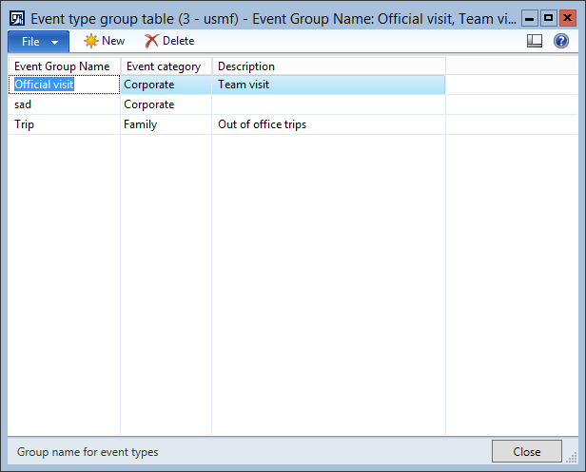

2. Click the New button.

3. Create a new record in the Event type group table form.

3. Change Event Group Name from '' to 'Out of office'.

4. Change Event category from 'Corporate' to 'Family'.

5. Change Description from '' to 'Out of office events'.

7. Make sure the selection is changed in table Event type group table to:

|  |  |  |
| --- | --- | --- |
| **Event Group Name** | **Event category** | **Description** |
| sad | Corporate |  |

6. Change Event Group Name from 'sad' to 'Meeting'.

9. Make sure the selection is changed in table Event type group table to:

|  |  |  |
| --- | --- | --- |
| **Event Group Name** | **Event category** | **Description** |
| Meeting | Corporate |  |

10. Click the Close toolbar button.

10. Change Description from '' to 'Meetings'.

12. Close the Event type group table form.

13. Click Area Page node: Event Management -> Setup -> Event Types.

Form name: Event type master table

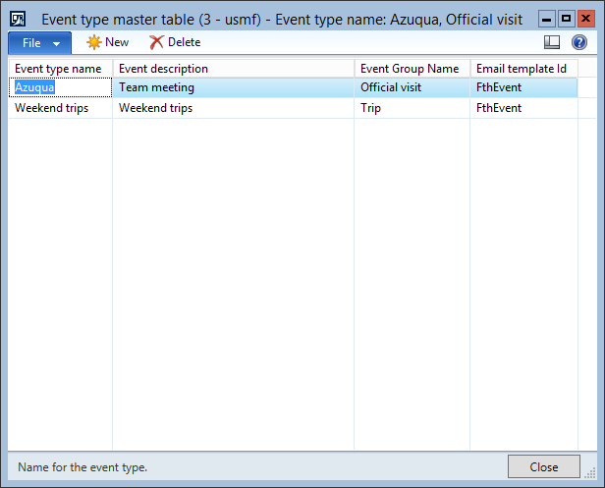

14. Click the New button.

15. Create a new record in the Event type master table form.

15. Change Event type name from '' to 'Overnite trips'.

16. Change Event description from '' to 'Overnite trips'.

17. Change Event Group Name from '' to 'Out of office'.

18. Change Email template Id from '' to 'FthEvent'.

20. Click the New button.

21. Create a new record in the Event type master table form.

21. Change Event type name from '' to 'Team meeting'.

22. Change Event description from '' to 'Team meeting'.

23. Change Event Group Name from '' to 'Meeting'.

25. Click the Close toolbar button.

25. Change Email template Id from '' to 'FthEvent'.

27. Close the Event type master table form.

28. Click Area Page node: Event Management -> Setup -> Food preference.

Form name: Food preferences

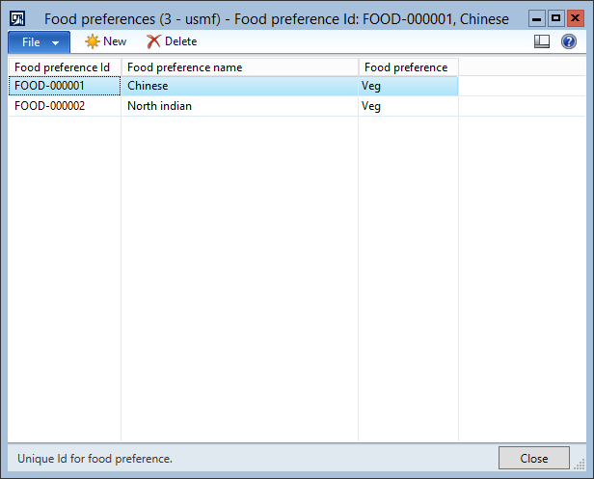

29. Click the New button.

30. Create a new record in the Food preferences form.

31. Click the Close toolbar button.

31. Change Food preference name from '' to 'Italian'.

33. Close the Food preferences form.

34. Click Area Page node: Event Management -> Setup -> Pickupdrop location.

Form name: Pickup drop location

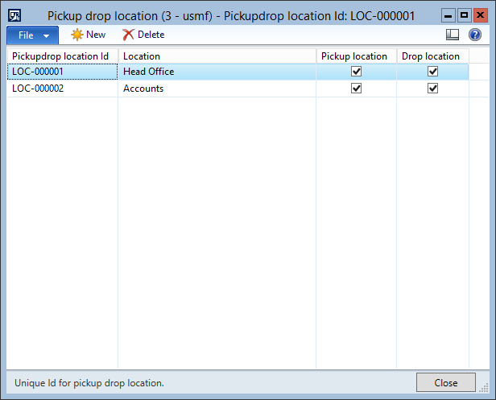

35. Create a new record in the Pickup drop location form.

35. Change Pickupdrop location Id from '' to 'LOC-000003'.

36. Change Pickup location from 'No' to 'Yes'.

37. Change Pickup location from 'Yes' to 'No'.

38. Change Pickup location from 'No' to 'Yes'.

40. Make sure the selection is changed in table Pickup drop location to:

|  |  |  |  |
| --- | --- | --- | --- |
| **Pickupdrop location Id** | **Name or description** | **Pickup location** | **Drop location** |
| LOC-000003 |  | Yes | No |

39. Change Name or description from '' to 'Office'.

42. Make sure the selection is changed in table Pickup drop location to:

|  |  |  |  |
| --- | --- | --- | --- |
| **Pickupdrop location Id** | **Name or description** | **Pickup location** | **Drop location** |
| LOC-000003 | Office | Yes | No |

43. Click the Close toolbar button.

43. Change Drop location from 'No' to 'Yes'.

45. Close the Pickup drop location form.

46. Click Area Page node: Event Management -> Setup -> Allergies.

Form name: Allergies master

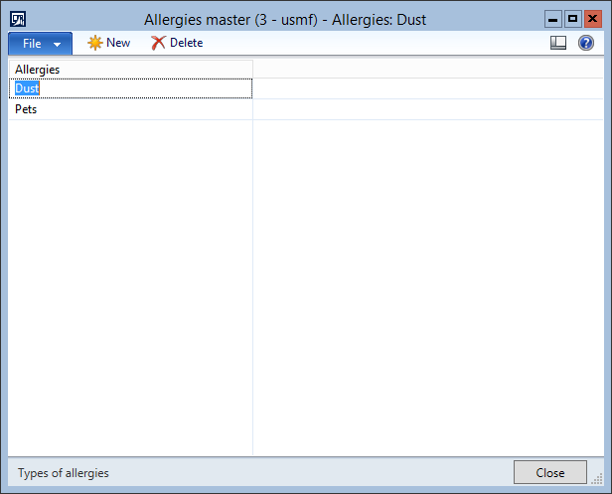

47. Click the New button.

48. Create a new record in the Allergies master form.

48. Change Allergies from '' to 'Cold'.

50. Click the New button.

51. Create a new record in the Allergies master form.

52. Click the Close toolbar button.

52. Change Allergies from '' to 'Hot'.

54. Close the Allergies master form.

55. Click Area Page node: Event Management -> Common -> Event details.

Form name: Event

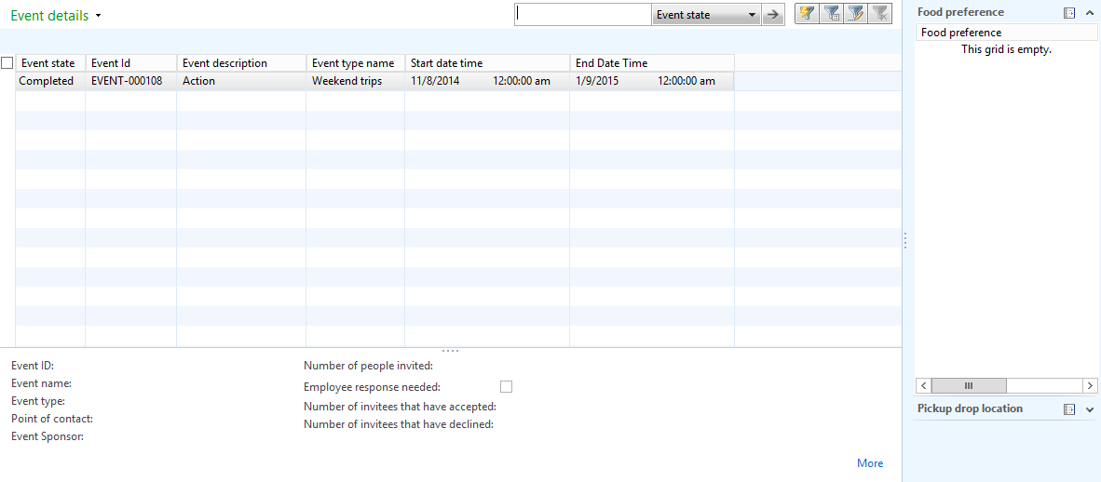

56. Click the Event -> New -> Event button.

57. Switch to the General tab on the Event form.

Form name: Event

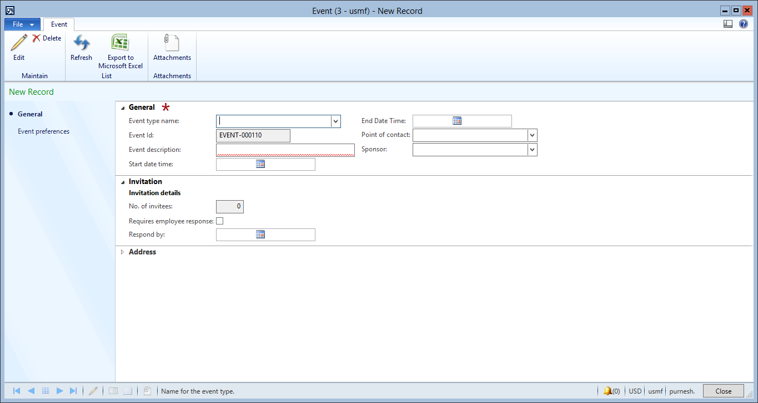

57. Change Event type name from '' to 'Overnite trips'.

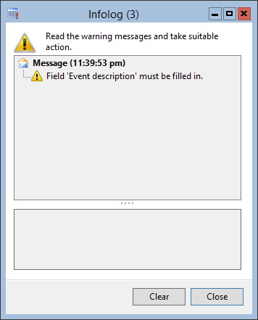

59. Click the Close button.

59. Change Event description from '' to 'Goa trip'.

60. Change Start date time from '' to '11/6/2014 12:00:00 am'.

61. Change End Date Time from '' to '11/8/2014 12:00:00 am'.

62. Change Name from '' to 'Aaron Con'.

63. Change Name from '' to 'Aaron Con'.

65. Switch to the Invitation tab on the Event form.

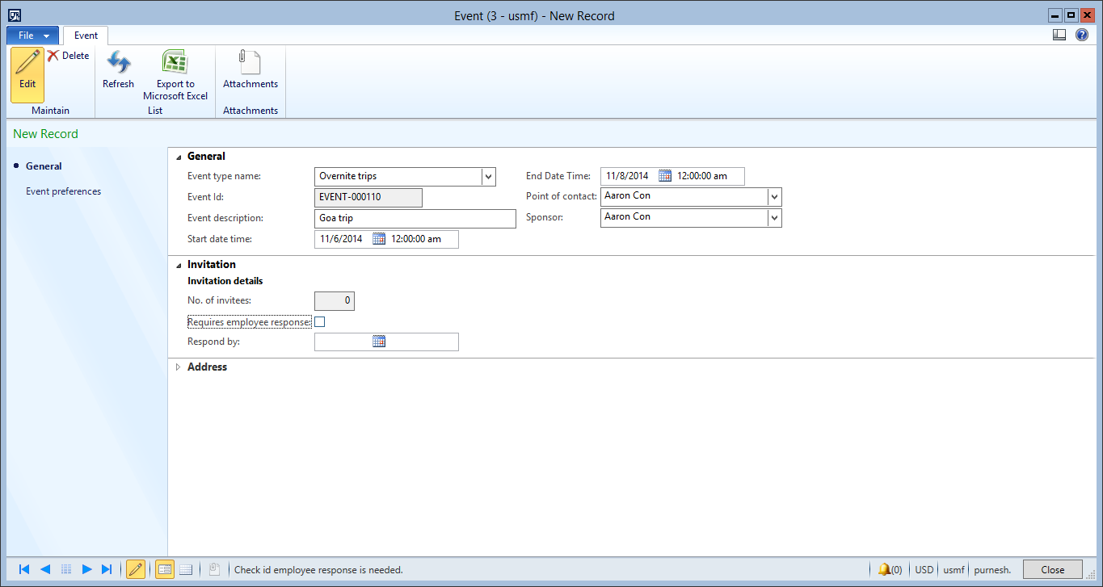

65. Change Requires employee response from 'false' to 'true'.

66. Change Respond by from '' to '11/2/2014 12:00:00 am'.

68. Switch to the Event preferences tab on the Event form.

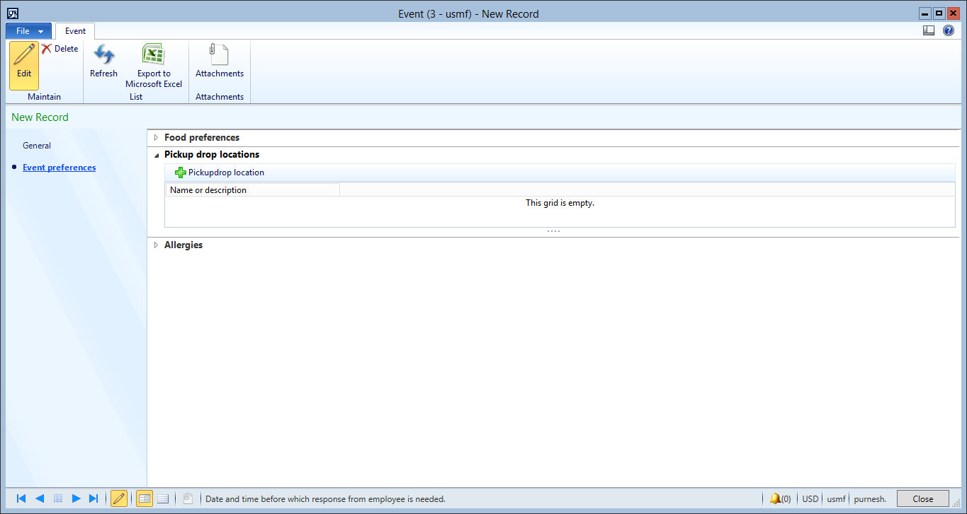

69. Switch to the Food preferences tab on the Event form.

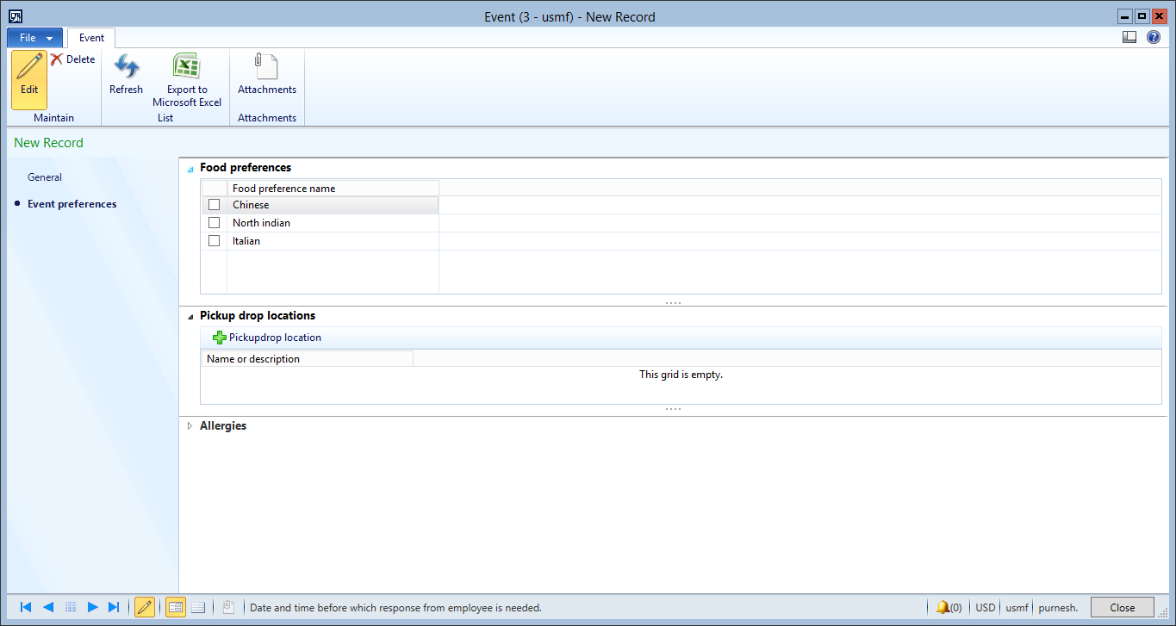

70. Make sure the selection is changed in table Food preferences to:

|  |  |
| --- | --- |
|  | **Food preference name** |
| false | North indian |

69. Change from 'false' to 'true'.

72. Make sure the selection is changed in table Food preferences to:

|  |  |
| --- | --- |
|  | **Food preference name** |
| false | Italian |

71. Change from 'false' to 'true'.

74. Switch to the Pickup drop locations tab on the Event form.

75. Click the Pickupdrop location button.

Form name: Pickup drop location

76. Switch to the Food preferences tab on the Event form.

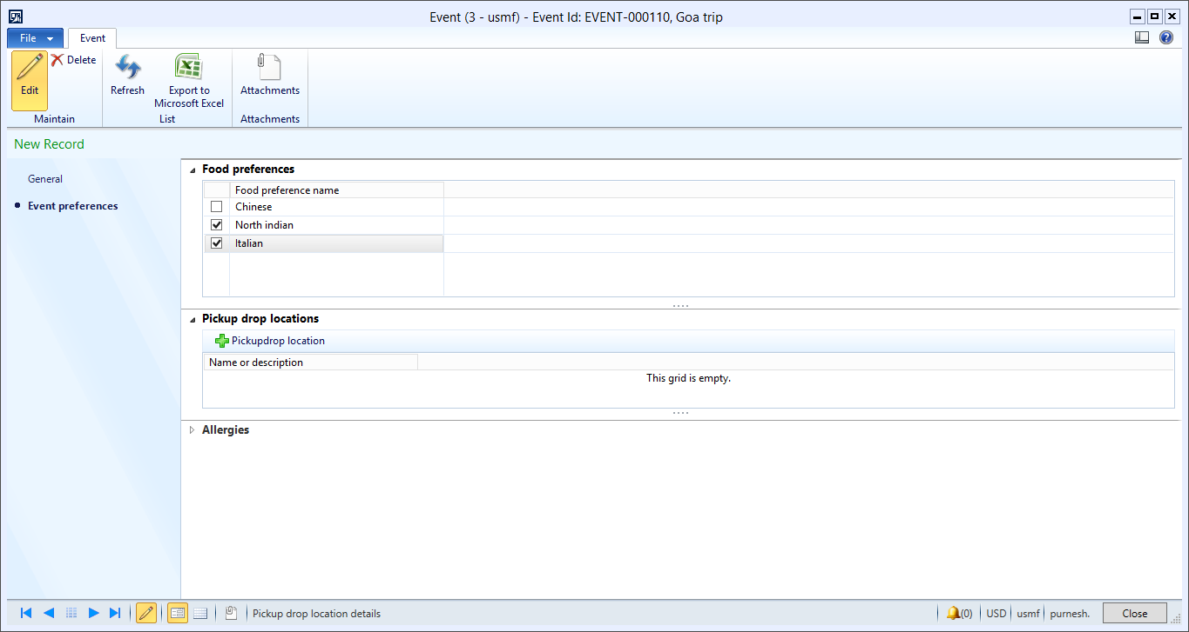

77. Make sure the selection is changed in table Pickup drop location to:

|  |  |  |  |  |
| --- | --- | --- | --- | --- |
|  | **Pickupdrop location Id** | **Name or description** | **Pickup location** | **Drop location** |
| false | LOC-000002 | Accounts | Yes | Yes |

76. Change from 'false' to 'true'.

79. Make sure the selection is changed in table Pickup drop location to:

|  |  |  |  |  |
| --- | --- | --- | --- | --- |
|  | **Pickupdrop location Id** | **Name or description** | **Pickup location** | **Drop location** |
| false | LOC-000001 | Head Office | Yes | Yes |

78. Change from 'false' to 'true'.

81. Make sure the selection is changed in table Pickup drop location to:

|  |  |  |  |  |
| --- | --- | --- | --- | --- |
|  | **Pickupdrop location Id** | **Name or description** | **Pickup location** | **Drop location** |
| false | LOC-000003 | Office | Yes | Yes |

82. Click the Close toolbar button.

82. Change from 'false' to 'true'.

84. Close the Pickup drop location form.

85. Switch to the Allergies tab on the Event form.

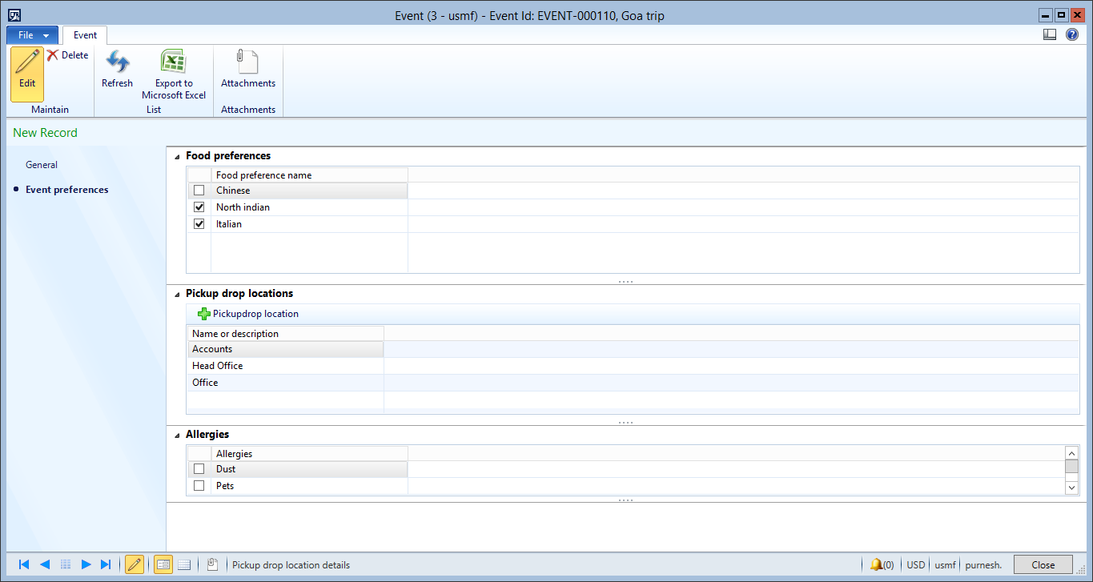

85. Change from 'false' to 'true'.

87. Make sure the selection is changed in table Allergies master to:

|  |  |
| --- | --- |
|  | **Allergies** |
| false | Cold |

86. Change from 'false' to 'true'.

89. Make sure the selection is changed in table Allergies master to:

|  |  |
| --- | --- |
|  | **Allergies** |
| false | Hot |

90. Click the Close toolbar button.

90. Change from 'false' to 'true'.

92. Close the Event form.

93. Click the Event -> Attendees Information -> Attendees Information button.

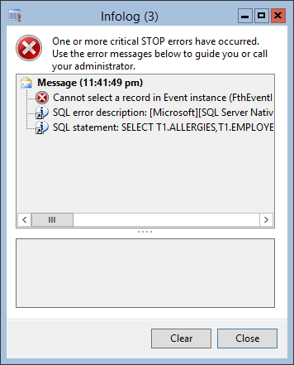

94. Click the Close button.